Alexander Baldree
03/25/26
Module 1 Assignment 1.3
CSD420

GitHub Link:
https://github.com/Panda-Alex21687/CSD420/tree/main/Module 1/Assignment 1.3

Maven Version:
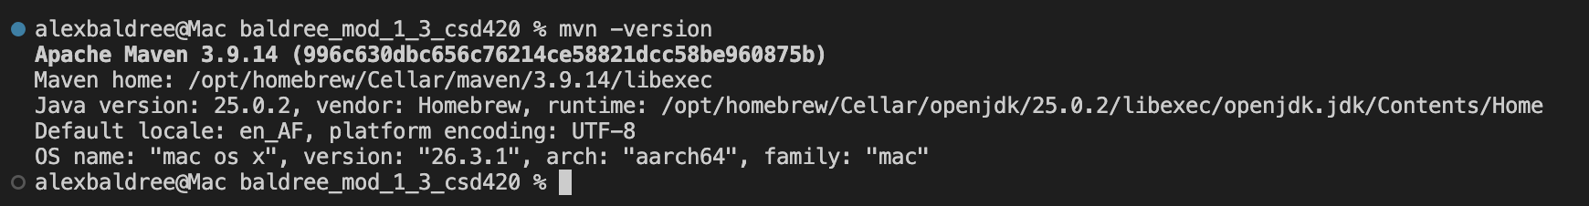

Code Layout Maven Project Correctly Integrated:
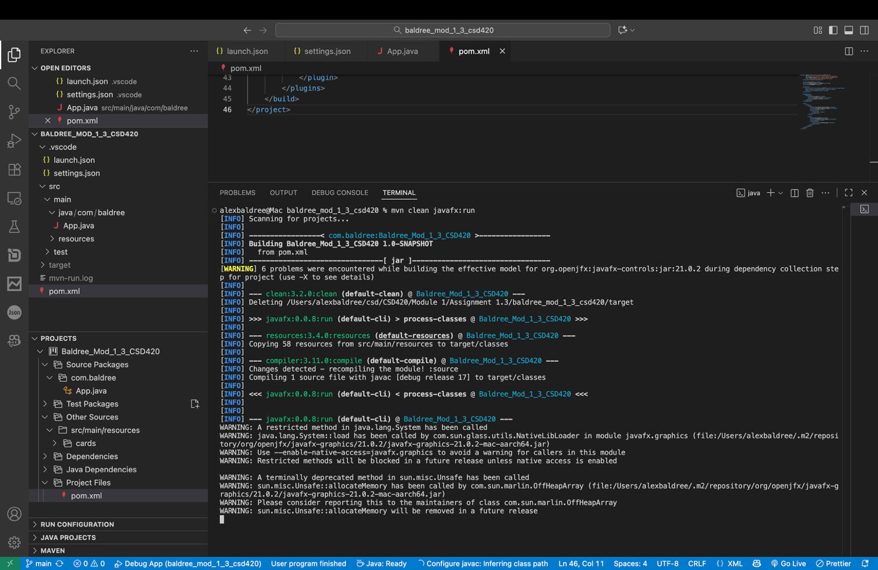
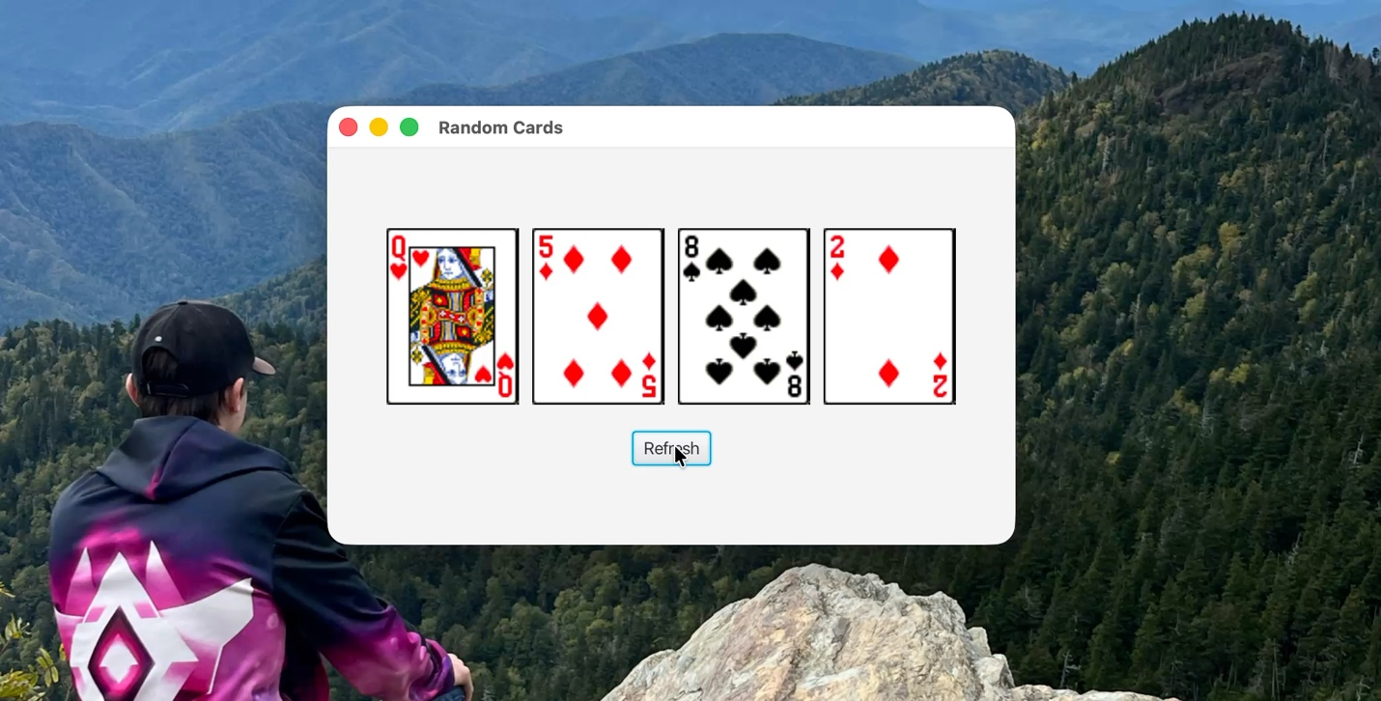
Output of code: when running (mvn javafx:run)
Right click and select: Play

